MINISTERO DELL’ISTRUZIONE DELL’UNIVERSITA’ E DELLA RICERCA UFFICIO SCOLASTICO REGIONALE PER LA PUGLIA
Istituto Comprensivo erchie
Scuola Infanzia – Scuola Primaria – Scuola Secondaria I grado
Ambito 11
Via Boccaccio,13 - 72020 Erchie (BR) Tel e Fax 0831-767645
C.M. BRIC80700L - C.F. 80006230744 – Codice Univoco Ufficio: UFIPKP
E-mail: BRIC80700L@istruzione.it - PEC: BRIC80700L@pec.istruzione.it - Sito web: www.icerchie.edu.it

 |  | 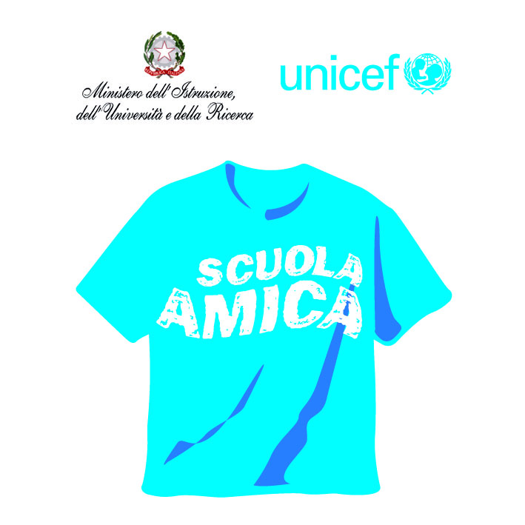 |   RegisteredExamination Centren. 10031
VERBALE RIUNIONE PER ADOZIONE LIBRI DI TESTO
anno scolastico 2022/2023

MATERIA: …………………………………………………….
COORDINATORE: …………………………………………
PRESENTI: ……………………………………………………………………………………………………………………………………………………………………………………………………………………………………………………………………………………………….
ORDINE DEL GIORNO:
……………………………………………………………………………………………………………………………………………..
VERBALE DELLA RIUNIONE
…………………………………………………………………………………………………………………………………………………………………………………………………………………………………………………………………………………………………………………………………………………………………………………………………………………………………………………………………………………………………………………………………………………………………………………………………………………………………………………………………………………………………………………………………………………………………………………………………………………………………………………………………………………………………………………………………………………………………………………………………………………………………………………………………………………………………………………………………………………………………………………………………………………………………………………………………………………………………………………………………………………………………………………………………………………………………………………………………………………………………………………………………………………………………………………………………………………………………………………………………………………………………………………………………………………………………………………………………………………………………………………………………………………………………………………………………………………………………………………………………………………………………………………………………………………………………………………………………………………………………………………………………………………………………………………………………………………………………………………………………………………………………………………………………………………………………………………………………………………………………………………………………………………………………………………………………………………………………………………………………………………………………………………………………………………………………………………………………………………………………………………………………………………………………………………………………………………………………………………………………………………………………………………………………………………………………………………………………………………………………………………………………………………………………………………………………………………………………………………………………………………………………………………………………………………………………………………………………………………………………………………………………………………………………………………………………………………………………………………………………………………………………………………………………………………………………………………………………………………………………………………………………………………………………………………………………………………………………………………………………………………………………………………………………………………………………………………………………………………………………………………………………………………………………………………………………………………………………………………………………………………………………………………………………………………………………………………………………………………………………………………………………………………………………………………………………………………………

La riunione termina alle ore………………………………

FIRME DEI PRESENTI:

___________________ ___________________
___________________ ___________________
___________________ ___________________

